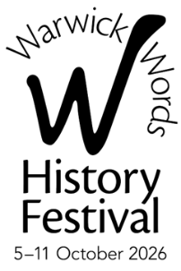
WARWICK WORDS HISTORY FESTIVAL 2026
CORPORATE PARTNERS & FRIENDS

SHARE OUR SUCCESS …

Festivals can have a substantial impact on the economic, cultural, and social life of any community.
By partnering with Warwick Words History Festival, you will convey positive messages about your
business and demonstrate, in an imaginative and creative way, a vital commitment to
corporate social responsibility.

BENEFITS AVAILABLE TO OUR CORPORATE SUPPORTERS

Main Partner – £1,000 – Be a Major Supporter of the Festival
Opportunity to sponsor a major author event during the Festival
Drinks reception for your guests
Company logo attached to the event in the Festival Guide and any other publicity for the event
Company logo on Sponsors’ page
Tickets to the event
Company branding and/or exhibition at the event
Corporate Friends benefits

Gold Partner – £500
Opportunity to sponsor one medium or a series of smaller events during the Festival
Company logo attached to the event in the Guide and any other publicity for the event
Company logo on Sponsors’ page
Tickets to the event(s)
Company branding and/or exhibition at the event
Corporate Friends benefits

Silver Partner – £250
Opportunity to sponsor a smaller event during the Festival
Company logo attached to the event in the Guide and any other publicity for the event
Company logo on Sponsors’ page
Tickets to the event
Company branding and/or exhibition at the event
Corporate Friends benefits

Bronze Partner – £150
Company logo on Sponsors’ page
Two tickets to one event
Corporate Friends benefits

Corporate Friends – £75
Company name in Festival Guide – distributed in central Warwickshire and beyond
Company logo and link on Festival website

