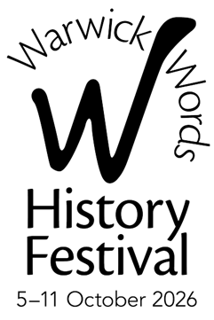

CORPORATE PARTNERS &
CORPORATE FRIENDS OF
WARWICK WORDS HISTORY FESTIVAL

APPLICATION FORM 2026: PLEASE COMPLETE CLEARLY

COMPANY: ………………….……………………………………….……………......................................................

CONTACT: ……..……………………………………………………………………….… TITLE: …………………….……………

ADDRESS: ..………….……..……………………………...............................................................................

………………..………………………………...….......................... POST CODE: …………………….…………….………

TEL: DAY: ……………………………………..…………………… EVE: ………………………………………….……………

EMAIL: …………..……………………………………………………………………....................................................

WEB: ……………..…………………………………………………………………….....................................................

PLEASE TICK AS APPROPRIATE:

□ Main Partner £1,000 □ Gold Partner £500 □ Silver Partner £250

□ Bronze Partner £150 □ Corporate Friend £75

□ Please include our company name/logo in the Festival brochure and/or on the website. (We will contact you for further details in due course.)

□ Please DO NOT include our company name/logo in the Festival brochure or on the website.

□ We enclose our CHEQUE (payable to Warwick Words) for £……………………

□ OR, FOR BANK PAYMENT: We have made a payment of £…………………...
to Lloyds Bank, Warwick: 30-99-15 Account 20633468 Warwick Words

□ Please retain our contact details on Warwick Words Corporate Supporters’ database.

SIGNATURE: ……………………………………………………………………………….………. DATE: …..……………………

PLEASE RETURN THE COMPLETED FORM WITH YOUR PAYMENT, OR PAYMENT ADVICE, TO:
Warwick Words, The Court House, Jury Street, Warwick CV34 4EW
Or email info@warwickwords.co.uk

THANK YOU

